Lemhee-Yekchi Chant Book

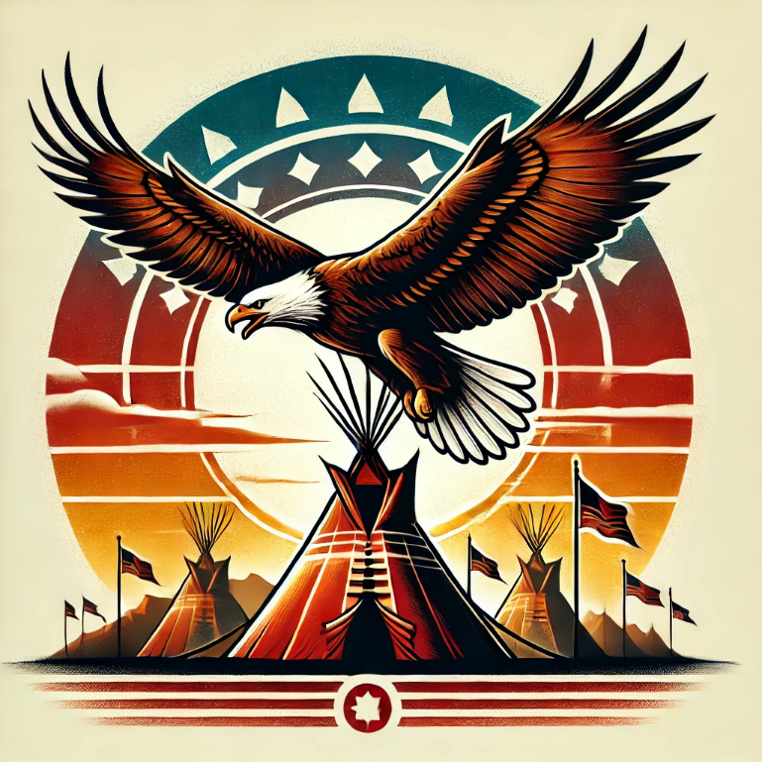

Tipisa Lodge, 326

We Can’t Spell Our Name: Part 1
Give me an L (echo L)
Give me an E (echo E)
Give me uhhhh (echo uhhhh)

We Can’t Spell Our Name: Part 2
We can’t spell our name
We can’t spell our name
We can’t spell our name
Lemhee Lemhee Lemhee
Yekchi Yekchi Yekchi

Rise Lemhee-Yekchi Rise
(to the tune of ants go marching down)
Lemhee-Yekchi, hear the call, (Hurray, Hurray) Brothers, sisters, one and all. (Hurray, Hurray) In Tipisa’s light, we stand tall, Service, honor, never fall!
Rise, rise, Lemhee-Yekchi, rise!
In forests deep and mountains high, (Hurray, Hurray) We light the way, our banners fly. (Hurray, Hurray) In Tipisa’s name, we won’t deny Lemhee-Yekchi, by and by!
Rise, rise, Lemhee-Yekchi, rise!
With a laugh and a cheer, we take the lead, (Hurray, Hurray) Pickles pickles, it’s all we need! (Hurray, Hurray) To Angry Birds, our spirits feed, Lemhee-Yekchi, we succeed!
Rise, rise, Lemhee-Yekchi, rise!
With burning crackers, we light the night, (Hurray, Hurray) A symbol strong, our flames ignite. (Hurray, Hurray) In Lemhee-Yekchi, our spirits bright, Together we march, through the night!
Rise, rise, Lemhee-Yekchi rise!
On a daring ride with nothing to hide, (Hurray, Hurray) We pedal fast, with pride as our guide! (Hurray, Hurray) Lemhee-Yekchi, wild and wide, together we roll, side by side!
Rise, rise, Lemhee-Yekchi, rise!
Big TT has yelled at me, (oh my!, oh my!) But I just smile and wonder why. (oh my!, oh my!) Lemhee-Yekchi, reach so high, Together we stand, never shy!
Rise, rise, Lemhee-Yekchi, rise!

Lemhee Rap

Chorus
Come and grab a seat, eat some Lemhee meat. Go ahead and chill, at the OA grill. Lemhee’s up all night, up until the light. All our fits real crisp lead by Daddy Chris.

Verse 1
Who’s the best it’s Lemhee. We got chants we got plenty. Chapter Chief and its Benny. We got members more than 20. Lemhee’s got the best rapper. Stay at NOAC burning crackers. They say “who’s the best chapter?” It is Lemhee the rest are rat turds. Lemhee wins we say hooray, like we did at the bike parade. Pine hills Chapter we getting braids. Best believe we deserve the glaze. On the grills we cooking glizzys, With the oil just like we Diddy. fortnite Chapters we hit the griddy.

Chorus
Come and grab a seat, eat some Lemhee meat. Go ahead and chill, at the OA grill. Lemhee’s up all night, up until the light. All our fits real crisp lead by Daddy Chris.

Verse 2
The game we love is Angry Birds, and we also love pickles. Benny talk so what’s the word? He said that we should tickle. Lemhee’s team is pretty scary. Taking bout pretty yeah we got Jerry. Favorite class is culinary.
Cause you know we stay cookin. Stealing flags no one’s lookin. All of our names are legal. Best Chapter Strong Eagles. Yeah we got the best people. Our bites hard like a beetle.
Never lost in tug of war, unless the others are cheating. Next time we gon practice more, next time they’ll be bleeding. Yeah you know we gonna win, Fighting hard right till the end. Dominance and its starts with Ben.

Chorus
Come and grab a seat, eat some Lemhee meat. Go ahead and chill, at the OA grill. Lemhee’s up all night, up until the light. All our fits real crisp lead by Daddy Chris.

Credits:
Benton Forrester
Ben Weger
Jacob Smith

